I have a domain name called agilean.in ..we can use that while hosting

Source code:

<https://github.com/kanboard/kanboard>

<https://docs.kanboard.org/en/latest/admin_guide/installation.html>

We need to take the above code – hosting.

--------------------------------------------------

Create a login page with sub-domain hosting process with wild card SSL certificate

Example: (reference agilecrm.com)

&

<https://www.youtube.com/watch?v=BIX1YnWkOAU>

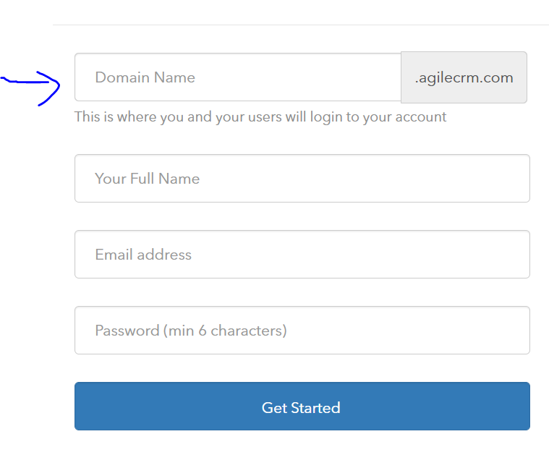

Domain name is as good as company name.

Anyone registers with their company name , example: if they give domain name/company name as wipro,

Then for that customer we should provide the link as wipro.agilean.in

Another company is registering with Infosys, then for that company url is Infosys.agilean.in

Customers data should not conflict . Not sure how you segregate the database.

Once we perform this, then we can develop other features.

We should be able to integrate with below app

https://github.com/becomist/strapi-okr-api